Equal Sides
# Source: AI Source: Provided by: [Data Path: Persons Table -> ID Column: 1, Name_En Column: Motasem Essam] -> From: [ChatGPT] on [7/25/2026]
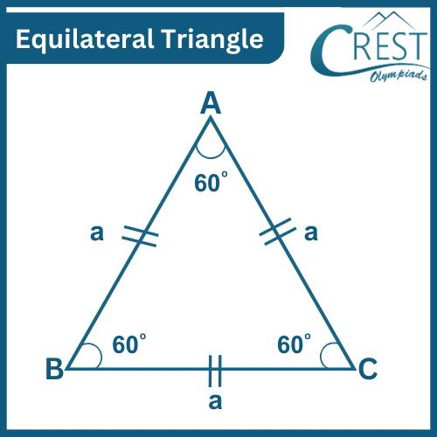
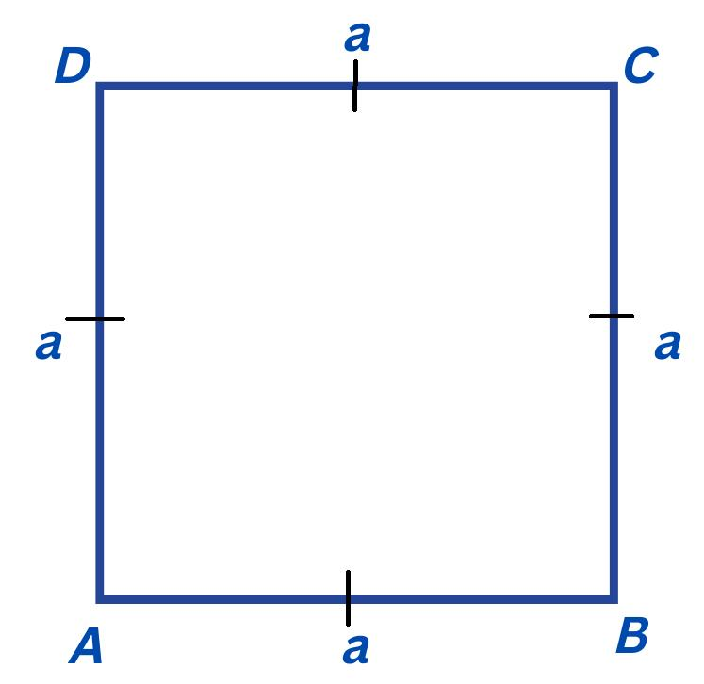
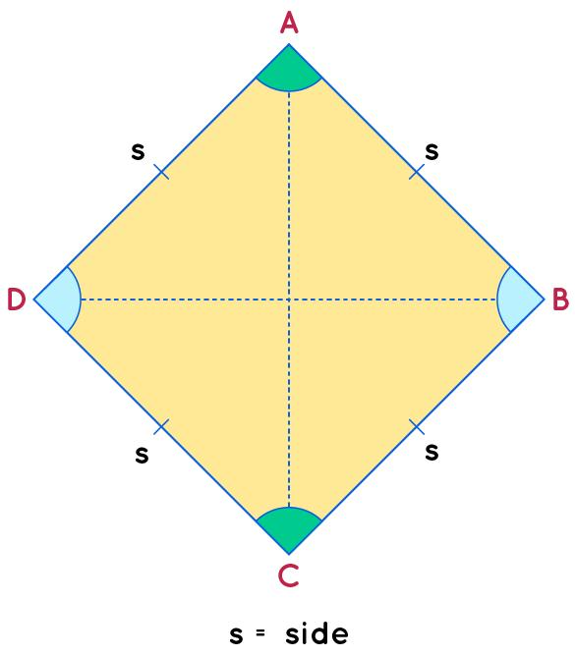
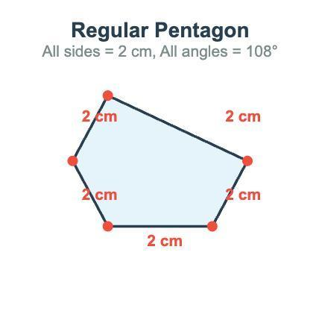

Definition
# Source: AI Source: Provided by: [Data Path: Persons Table -> ID Column: 1, Name_En Column: Motasem Essam] -> From: [ChatGPT] on [7/25/2026]
Equal Sides are two or more sides of the same geometric figure that have exactly the same length. In geometry, equal sides are also called congruent sides because they are identical in length, even if they have different positions or orientations.
Equal sides are an important property used to classify many geometric figures.

Characteristics
# Source: AI Source: Provided by: [Data Path: Persons Table -> ID Column: 1, Name_En Column: Motasem Essam] -> From: [ChatGPT] on [7/25/2026]
Equal sides:
- Have the same length.
- Are represented by identical measurement values.
- Are often indicated in diagrams using matching tick marks.
- May be adjacent or opposite.
- Help determine the type and symmetry of a shape.

Illustration

Equilateral Triangle
# Source: AI Source: Provided by: [Data Path: Persons Table -> ID Column: 1, Name_En Column: Motasem Essam] -> From: [ChatGPT] on [7/25/2026]
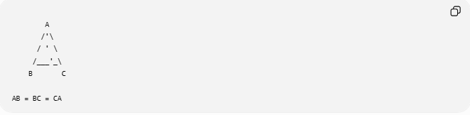
A
/'\
/ ' \
/___'_\
B C

AB = BC = CA
All three sides are equal.

Square
# Source: AI Source: Provided by: [Data Path: Persons Table -> ID Column: 1, Name_En Column: Motasem Essam] -> From: [ChatGPT] on [7/25/2026]
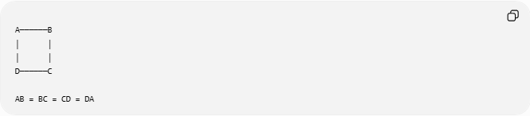
A──────B
│ │
│ │
D──────C

AB = BC = CD = DA
All four sides are equal.

Rhombus
# Source: AI Source: Provided by: [Data Path: Persons Table -> ID Column: 1, Name_En Column: Motasem Essam] -> From: [ChatGPT] on [7/25/2026]
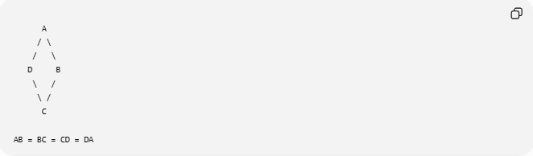
A
/ \
/ \
D B
\ /
\ /
C

AB = BC = CD = DA
A rhombus has four equal sides, but its angles are not necessarily right angles.

Mathematical Representation
# Source: AI Source: Provided by: [Data Path: Persons Table -> ID Column: 1, Name_En Column: Motasem Essam] -> From: [ChatGPT] on [7/25/2026]
If two sides are equal:
$$\overline{AB}=\overline{CD}$$
If all sides of a polygon are equal:
$$\overline{AB}=\overline{BC}=\overline{CD}=⋯$$

Tick Mark Notation
# Source: AI Source: Provided by: [Data Path: Persons Table -> ID Column: 1, Name_En Column: Motasem Essam] -> From: [ChatGPT] on [7/25/2026]
Equal sides are commonly shown using identical tick marks.
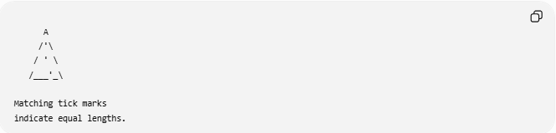
A
/'\
/ ' \
/___'_\

Matching tick marks
indicate equal lengths.

Examples
# Source: AI Source: Provided by: [Data Path: Persons Table -> ID Column: 1, Name_En Column: Motasem Essam] -> From: [ChatGPT] on [7/25/2026]
Example 1 – Equilateral Triangle
$$AB=BC=CA$$
All sides are equal.

Example 2 – Square
$$AB=BC=CD=DA$$
All sides are equal.

Example 3 – Isosceles Triangle
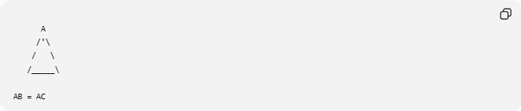
A
/'\
/ \
/_____\

AB = AC
Only two sides are equal.

Example 4 – Regular Pentagon
Every side has the same length.

Shapes with Equal Sides
# Source: AI Source: Provided by: [Data Path: Persons Table -> ID Column: 1, Name_En Column: Motasem Essam] -> From: [ChatGPT] on [7/25/2026]
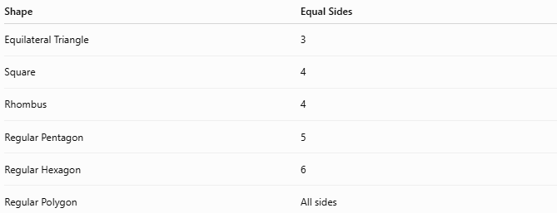
Shape | Equal Sides
Equilateral Triangle | 3
Square | 4
Rhombus | 4
Regular Pentagon | 5
Regular Hexagon | 6
Regular Polygon | All sides

Properties
# Source: AI Source: Provided by: [Data Path: Persons Table -> ID Column: 1, Name_En Column: Motasem Essam] -> From: [ChatGPT] on [7/25/2026]
1. Congruence
Equal sides are congruent.

2. Symmetry
Figures with equal sides usually have one or more lines of symmetry.

3. Shape Classification
Equal sides help identify figures such as:
- Equilateral triangles.
- Squares.
- Rhombuses.
- Regular polygons.

4. Equal Angles (Sometimes)
In regular polygons, equal sides imply equal interior angles.
However, this is not always true.
Example:
A rhombus has equal sides but not necessarily equal angles.

Real-World Examples
# Source: AI Source: Provided by: [Data Path: Persons Table -> ID Column: 1, Name_En Column: Motasem Essam] -> From: [ChatGPT] on [7/25/2026]
Equal sides appear in:
- Floor tiles.
- Chessboards.
- Stop signs (regular octagons).
- Honeycomb cells (regular hexagons).
- Decorative patterns.
- Picture frames.
- Windows.
- Architectural designs.

Applications
# Source: AI Source: Provided by: [Data Path: Persons Table -> ID Column: 1, Name_En Column: Motasem Essam] -> From: [ChatGPT] on [7/25/2026]
Equal sides are used in:
- Plane Geometry
- Coordinate Geometry
- Engineering
- Architecture
- CAD (Computer-Aided Design)
- Surveying
- Computer Graphics
- Robotics
- Industrial Design
- Manufacturing

Advantages
# Source: AI Source: Provided by: [Data Path: Persons Table -> ID Column: 1, Name_En Column: Motasem Essam] -> From: [ChatGPT] on [7/25/2026]
Studying equal sides helps to:
- Classify polygons.
- Solve geometric proofs.
- Compute missing lengths.
- Analyze symmetry.
- Construct regular figures.

Limitations
# Source: AI Source: Provided by: [Data Path: Persons Table -> ID Column: 1, Name_En Column: Motasem Essam] -> From: [ChatGPT] on [7/25/2026]
Equal sides alone do not determine a figure uniquely.
For example:
- A square and a rhombus both have four equal sides, but only the square has four right angles.

Comparison with Related Concepts
# Source: AI Source: Provided by: [Data Path: Persons Table -> ID Column: 1, Name_En Column: Motasem Essam] -> From: [ChatGPT] on [7/25/2026]
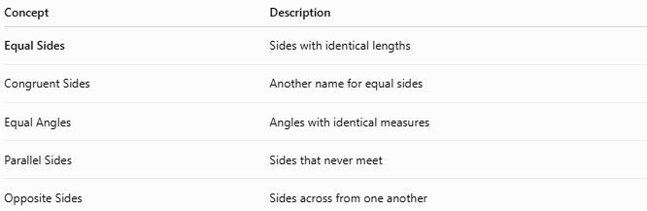
Concept | Description
Equal Sides | Sides with identical lengths
Congruent Sides | Another name for equal sides
Equal Angles | Angles with identical measures
Parallel Sides | Sides that never meet
Opposite Sides | Sides across from one another

Key Points
# Source: AI Source: Provided by: [Data Path: Persons Table -> ID Column: 1, Name_En Column: Motasem Essam] -> From: [ChatGPT] on [7/25/2026]
- Equal Sides have exactly the same length.
- They are also called congruent sides.
- Equal sides are commonly shown using matching tick marks.
- Many regular figures are defined by equal sides.
- Equal sides help classify and analyze geometric figures.

Conclusion
# Source: AI Source: Provided by: [Data Path: Persons Table -> ID Column: 1, Name_En Column: Motasem Essam] -> From: [ChatGPT] on [7/25/2026]
Equal Sides are sides of a geometric figure that have identical lengths. They are a defining characteristic of many important shapes, including equilateral triangles, squares, rhombuses, and regular polygons. Equal sides play a fundamental role in plane geometry, coordinate geometry, engineering, architecture, CAD, surveying, computer graphics, robotics, industrial design, and manufacturing, where they are used to classify figures, establish congruence, analyze symmetry, and solve geometric problems.

